|  |  |  |  |  |  |
| --- | --- | --- | --- | --- | --- |
| A | B | QA | QB | QC | Y |
| L | L | ON | ON | OFF | H |
| L | H | ON | OFF | ON | L |
| H | L | OFF | ON | OFF | Z |
| H | H | OFF | OFF | ON | L |

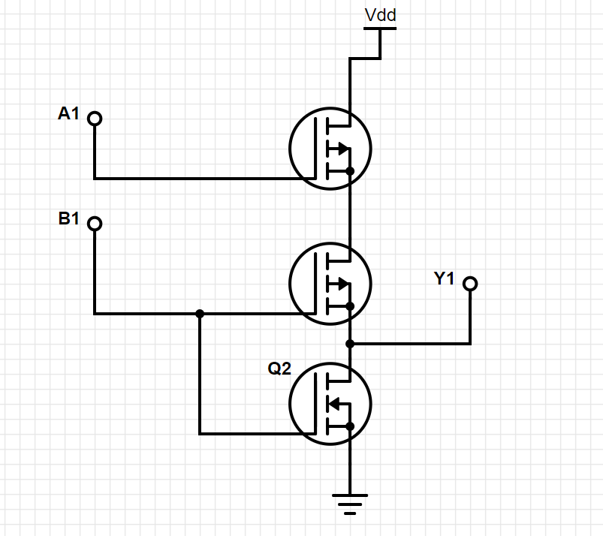

|  |  |  |  |  |  |
| --- | --- | --- | --- | --- | --- |
| A | B | QA | QB | QC | Y |
| L | L | ON | OFF | OFF | H |
| L | H | ON | OFF | ON | H |
| H | L | OFF | ON | OFF | Z |
| H | H | OFF | ON | ON | L |

